People around the globe, in Keene, cast eyes to the skies

MOON WATCHERS
Norma Pinney of Swanzey takes a photograph of the moon by holding the camera close to the eyepiece of a telescope set up at Ashuelot River Park Saturday evening during International Observe the Moon Night. STEVE HOOPER / Sentinel Staff

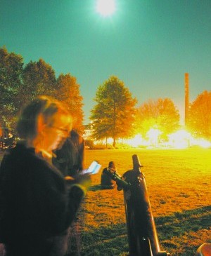
Posted: Monday, October 10, 2011 12:15 pm
By Abby Spegman Sentinel Staff | 1 comment
A LUNAR MOMENT
MOON WATCHERS
People around the globe, in Keene, cast eyes to the skies
They stood in a dark corner of Ashuelot River Park Saturday evening — about a dozen people, necks craned, eyes squinted over telescope lenses.
“Is this some event or something?” a young man with a bike asked a woman standing by one of the three telescopes that were fixed on a point toward the southeast.
“No, we’re just looking at the moon,” she said causally.
This was the scene that played out at hundreds of locations on six continents for International Observe the Moon Night on Saturday. It was an effort, organizers said, to “instill in the public a sense of wonderment and curiosity” about the moon, according to the group’s website.
The Keene event was hosted by the Keene Public Library in coordination with the Keene Amateur Astronomers Club. The library received a $500 grant through the Observe the Moon Night organization to purchase a lunar binocular, which will now be available for rental though the library.
“We’re still learning how to use it,” said Gail E. Zachariah, head of youth and community services at the library.
The astronomy club brought along two more telescopes. The club has its own observatory in Sullivan and is planning to host a lecture series and lunar photo exhibit at the library early next year.
The observation was a good promotion for the club, which has about 15 active members, as well as for the moon, said the club’s president, James G. Fox.
“The biggest theory right now (about the moon’s formation) is that a Mars-size planet crashed into our planet when it was really young,” he noted.
Scientists have discovered ice on the moon. They have also found rocks similar to those found on Earth, Fox said.
Saturday’s event was well timed. The best time to observe the moon is not when it’s full, said Keith Goodale, an adjunct astronomy professor at Keene State College.
“It’s right before the full moon or right after,” he said. Saturday’s was a waxing gibbous moon — before a full moon. (What comes after a full moon is called a waning gibbous moon.)
Which means the next best time for observation will be after Wednesday’s full moon.

